US Grade 4 – Pre-test
10 Questions | 30-45 minutes | Calculator not allowed
1. Which set of numbers are all multiples of 12?
- 24, 36, 46, 60
- 1, 12, 24, 36
- 1, 2, 3, 4, 6, 12
- 12, 24, 36, 48

2. Nigel volunteers at an animal shelter. They have 48 pounds of dog food. Nigel feeds the dogs in servings of ounces. How many ounces of dog food does the animal shelter have? (1 pound = 16 ounces)
- 48 ounces
- 3 ounces
- 768 ounces
- 722 ounces

3. How many lines of symmetry does the figure below have?
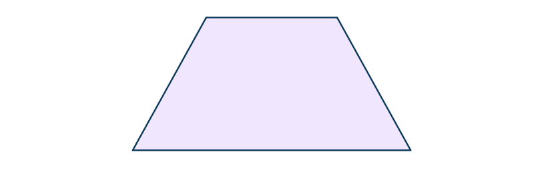
- 1
- 4
- 0
- 2

4. Which of the following numbers round to 900 when rounded to the nearest hundred?
- 945
- 987
- 846
- 785

5. What is the value of point X on the number line below?
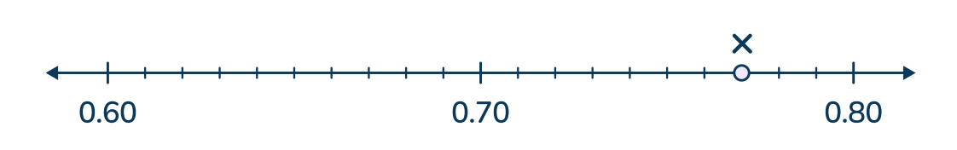
- 0.14
- 0.77
- 0.73
- 0.83

6. Ursula subtracted with the standard algorithm.

What mistake did Ursula make?
- She did not make any mistakes.
- She did not line up the place values correctly.
- She did not carry the extra hundred to make 8 hundreds on top
- She did not borrow 1 ten to subtract 8 from 11 ones.

7. The right triangle below is divided into two parts.
The measure of angle ABC is 56 degrees.
What is the measure of angle CBD?
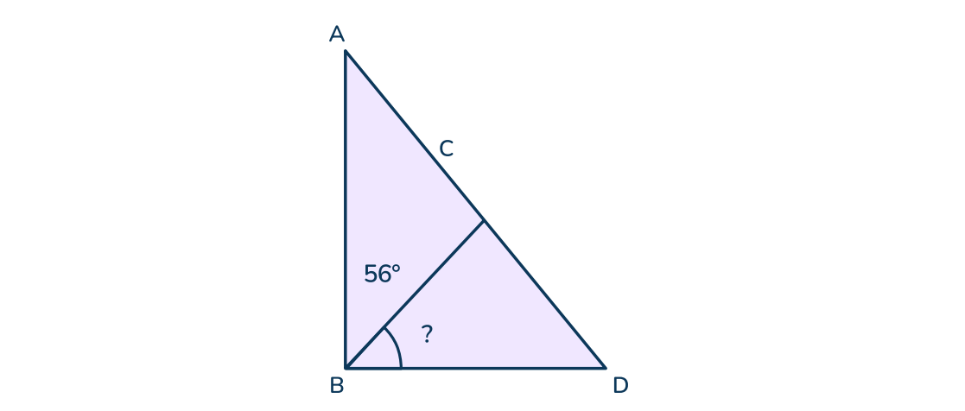
- 34
- 56
- 90
- 45
8. Starting number: 137
Rule: add 13 each time
Which statement is true about the numbers in the pattern?
- All the numbers are even.
- All the numbers are odd.
- The numbers alternate between even and odd.
- The first number is odd and the rest are even.

9. Eli read for 35 minutes. Then he played his video game for 1 hour, before he spent time eating lunch. If he started reading at 9:50am and finished eating lunch at 12:05pm, how long did he spend eating lunch?
- 40 minutes
- 25 minutes
- 35 minutes
- 20 minutes
10. Fatima and Stephanie each ran at a track meet.
Fatima ran $\frac{3}{4}$ miles.
Stephanie ran 5 times as far as Fatima.
How many miles did Stephanie run?
- 3$\frac{3}{4}$
- $2\frac{1}{4}$
- 1$\frac{1}{2}$
- 4$\frac{1}{4}$

